1. Lecture plan
 | Topic | Teaching focus
 | Introduction to knowledge and reasoning | Why AI needs knowledge
 | Knowledge-based agents | Architecture and working cycle
 | Propositional logic | Propositions, operators, examples
 | First-order logic | Predicates, variables, quantifiers

2. Introduction to knowledge and reasoning

2.1 What is knowledge in AI?
- Knowledge is information that an AI system can use to understand a situation or make a decision.
- Knowledge may include facts, rules, relationships, and previous observations.
- AI uses knowledge to interpret input, draw conclusions, and choose actions.
Example: A smart building system stores these facts:
- Smoke is detected in Room A.
- If smoke is detected, an alarm must be activated.
The system uses the fact and the rule to conclude that the alarm should be activated.
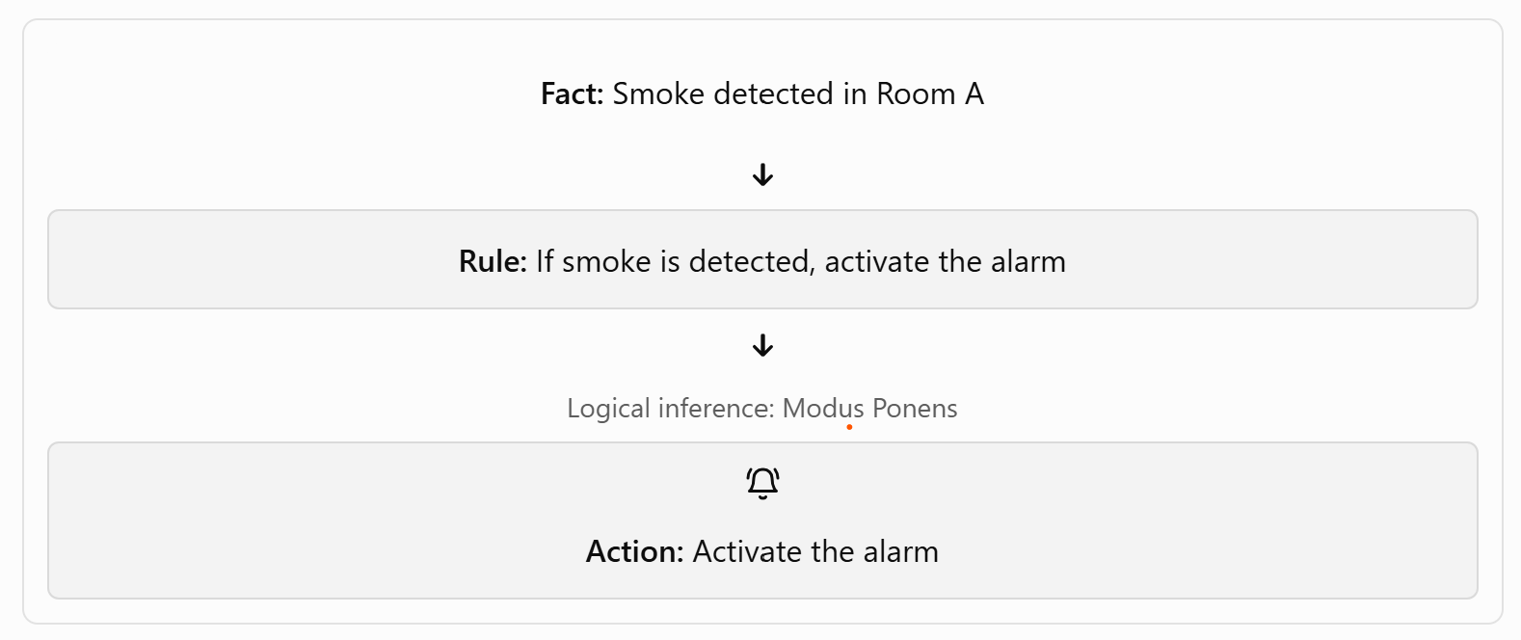

Modus Ponens
Definition: Modus Ponens is a logical reasoning rule used to derive a conclusion from a fact and a conditional rule.
Modus Ponens = Rule + Matching Fact → Conclusion. It is a fundamental inference rule used in knowledge-based AI systems.
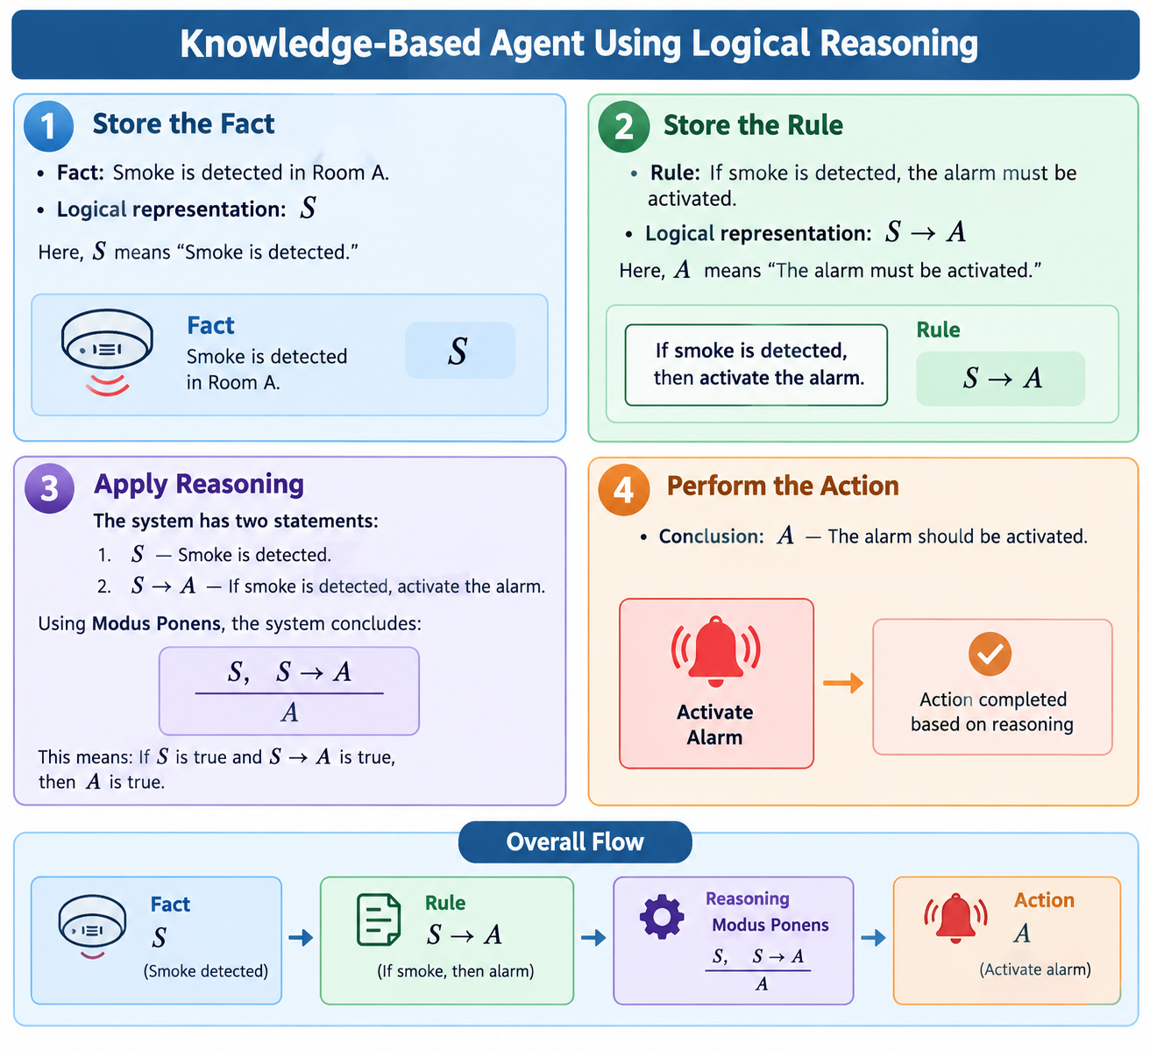

2.2 What is reasoning in AI?
Reasoning is the process of deriving a conclusion from available facts and rules.
Example:
- Fact: All humans are mortal.
- Fact: Ravi is a human.
- Conclusion: Ravi is mortal.
The conclusion is derived from the two facts. This is an example of logical reasoning.

2.3 Why does AI need knowledge and reasoning?
- To make decisions based on facts.
- To solve problems systematically.
- To infer information that is not directly provided.
- To explain how a conclusion was reached.
- To respond when new information becomes available.
Question: What is the difference between storing information and using information to make a decision?
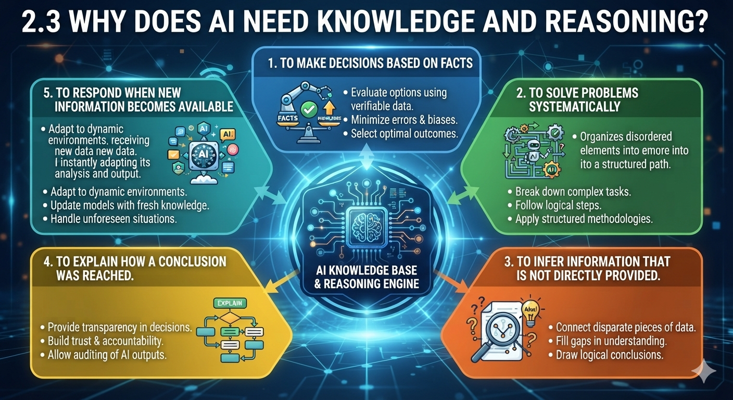

2.3 Why does AI need knowledge and reasoning?
  - To make decisions based on facts.
  - To solve problems systematically.
  - To infer information that is not directly provided.
  - To explain how a conclusion was reached.
  - To respond when new information becomes available.

6. Knowledge-based agent
- Environment: The surroundings or situation in which the AI agent operates.
- Percepts / Input: Information received from sensors or users.
- Knowledge Base: Stores facts, rules, and information required for reasoning.
- Inference Engine: Applies logical rules to existing facts to derive conclusions.
- Action / Output: Performs an action or provides a recommendation based on the conclusion.

7. Distinction
- Knowledge: If smoke is detected, activate the alarm.
- Logic: Smoke is detected.
- Reasoning: Therefore, activate the alarm.
- Action: The alarm is activated.

8. Quick answers for the final assessment
Question | Answer
What is a knowledge-based agent? | An agent that uses stored knowledge and inference to decide what to do.
What does a knowledge base contain? | Facts and rules.
What is an inference engine? | A component that applies rules to derive conclusions.
What is a proposition? | A statement that is either true or false.

Propositional Logic and First-Order Logic (FOL)

- Propositional logic works with complete statements, while First-Order Logic provides a richer way to represent objects, properties, relationships, and general rules.

1. Propositional Logic
Definition: Propositional Logic represents a statement that is either True or False.
Examples:
- P: The sun rises in the east. — True
- Q: It is raining. — This can be True or False depending on the weather.
Propositional logic combines statements using logical operators.

2. Logical Operators
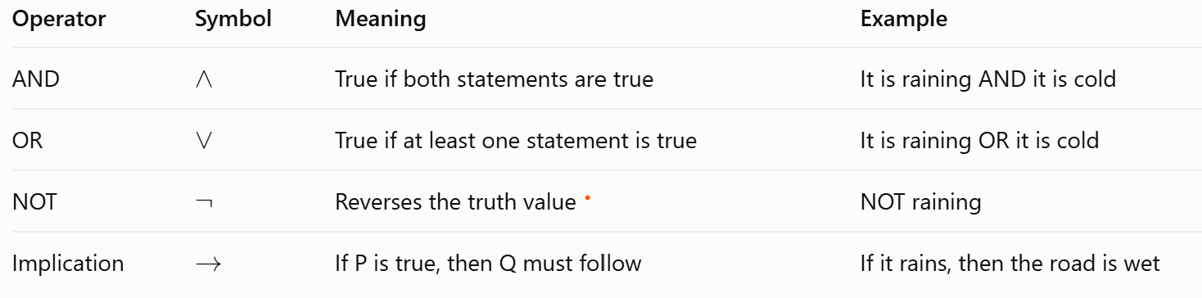
Example
Let P = “The student studies” and Q = “The student passes.”
The expression P->Q means:
“If the student studies, then the student passes.”
Note: Implication is false only when P is True and Q is False.

3. First-Order Logic (FOL)
Definition: First-Order Logic represents objects, their properties, and relationships between them.
Unlike propositional logic, FOL can describe individual objects and general rules.
Example:
- Object: Ravi
- Property: Ravi is a student.
- Predicate: Student(Ravi)
Here, Student(x) means “x is a student.” When x = Ravi, it becomes Student(Ravi).
Other examples:
- Human(Socrates) — Socrates is a human.
- Likes(Ravi, Python) — Ravi likes Python.
- GreaterThan(10, 5) — 10 is greater than 5.

4. Quantifiers
Quantifiers specify how many objects satisfy a condition.

Universal Quantifier (∀)
Means “for all” or “every.”
Example:
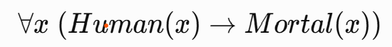
Meaning: All humans are mortal.

Existential Quantifier (∃)
Means “there exists at least one.”
Example:
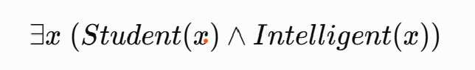
Meaning: At least one student is intelligent.
The AI system applies the general rule to the specific fact and derives a conclusion.

5. Applications in AI
- Knowledge Representation: Stores facts and rules about the world.
- Expert Systems: Uses rules to solve domain-specific problems.
- Automated Reasoning: Derives conclusions from known facts.
- Robotics: Represents objects, conditions, and relationships.
- Intelligent Decision-Making: Uses logical rules to select appropriate actions.

Key Difference
Propositional Logic | First-Order Logic
Represents complete statements | Represents objects and relationships
Uses True/False propositions | Uses predicates and quantifiers
Cannot directly express “all humans” | Can express “all humans”
Example: P → Q | Example: ∀x (Human(x) → Mortal(x))

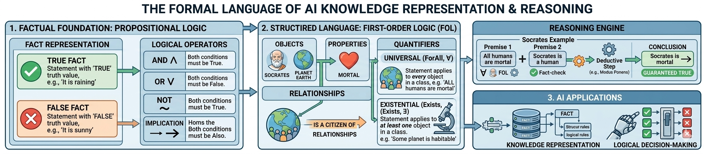

Automated Reasoning and Resolution

Automated reasoning is the overall process, inference rules provide the logical steps, and resolution is one technique for proving a conclusion through contradiction.

1. Automated Reasoning
Automated reasoning enables an AI system to derive new conclusions from known facts and rules.
Example:
- All humans are mortal.
- Ravi is a human.
- Therefore, Ravi is mortal.

2. Inference Rules
Inference rules are logical methods used to reach conclusions from existing statements.
Example:
- If a student studies, the student passes.
- Ravi studies.
- Therefore, Ravi passes.
This is called Modus Ponens.

3. Resolution
Resolution is a logical technique used to prove a statement by combining clauses and identifying contradictions.
Example:
- If P is true, then Q is true.
- P is true.
- Therefore, Q is true.

4. Working Process of Resolution
- Convert facts and rules into logical clauses.
- Negate the conclusion to be proved.
- Apply resolution to the clauses.
- If a contradiction (empty clause) occurs, the original conclusion is proved.

5. Example: Socrates Is Mortal
- Rule: All humans are mortal.
- Fact: Socrates is a human.
- Conclusion: Socrates is mortal.
Resolution negates the conclusion and combines it with the rule and fact. This produces a contradiction, proving that Socrates is mortal.

6. Applications in AI
- Automated theorem proving
- Logic programming, such as Prolog
- Knowledge-based systems
- Expert systems
- Software verification

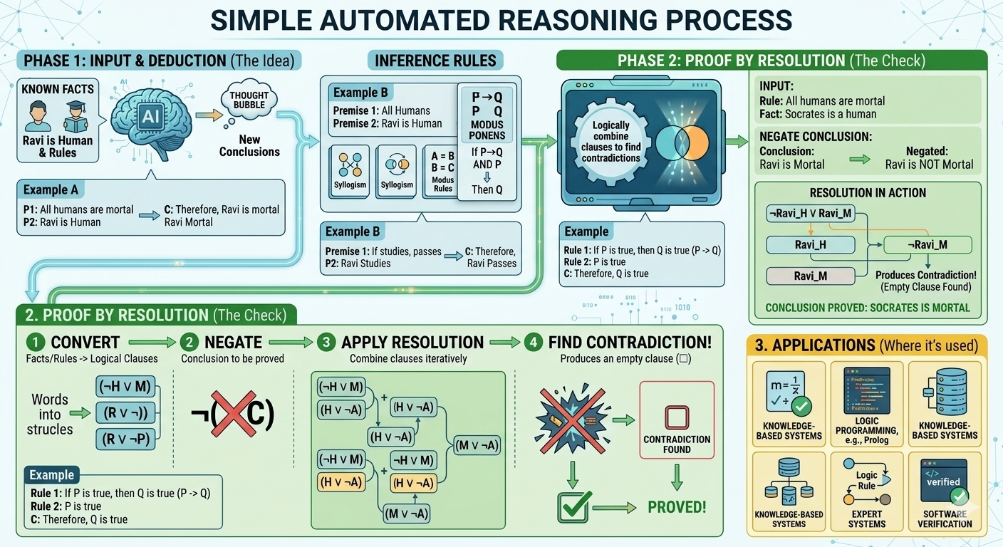

Expert Systems and Certainty Factors

An expert system uses a knowledge base to store facts and rules, an inference engine to draw conclusions, and certainty factors to represent confidence in uncertain conclusions.

1. Expert Systems
An expert system is an AI program that uses expert knowledge and rules to solve problems in a specific domain.
Example: A system that helps identify possible machine faults.

2. Knowledge Base
The knowledge base stores facts and IF–THEN rules used by the system.
Example: IF a machine is overheating, THEN check the cooling system.

3. Inference Engine
The inference engine applies rules to known facts to generate conclusions or recommendations.
Example: If the temperature is high and the fan is not working, it recommends checking the fan.

4. Certainty Factors (CF)
Certainty factors represent the degree of confidence in a conclusion when information is uncertain. In some expert systems, CF values range from −1 to +1.
- +1: Complete confidence in the conclusion
- 0: No confidence either way
- −1: Complete confidence that the conclusion is false

5. Example
Rule: IF fever AND cough, THEN a possible respiratory infection.
If the system assigns a certainty factor of +0.7, it indicates confidence in that conclusion within the system's model. It does not mean there is a medically verified 70% probability of infection.

6. Applications in AI
- Equipment fault detection
- Technical troubleshooting
- Medical decision support
- Financial decision support
- Industrial monitoring
